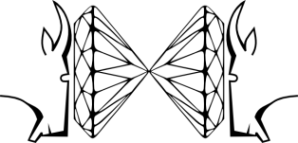
FROLIC GOATS
HIGH-PRESSURE DIFRACTION WORKSHOP
May 13-15, 2018 Poznań

CONTACT DETAILS
First name and surname
Scientific title/degree
E-mail
Institution
Correspondence address
PRESENTATION
Type of participation | Only participation
 | Poster
 | Oral 15 min
 | Oral 30 min
 | Oral 45 min
Title of presentation

